**Design**

**1-Registration feature**

**Class Diagram**

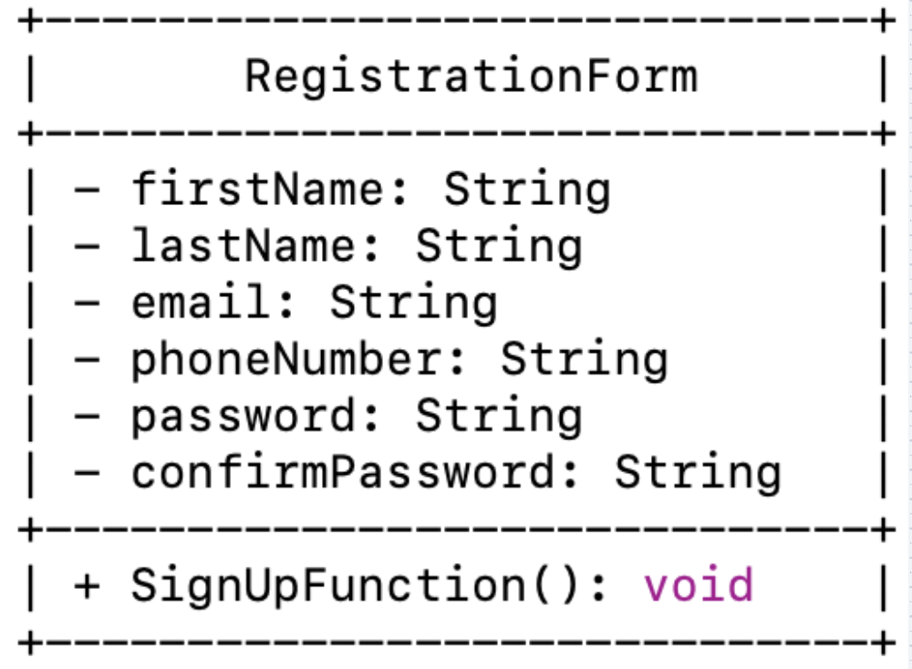

**Name:Design_FEAT001_ClassDiagram_001**

**Name: Design_FEAT001_Lowlevel_001**

**2-Login Feature**

**Class Diagram**

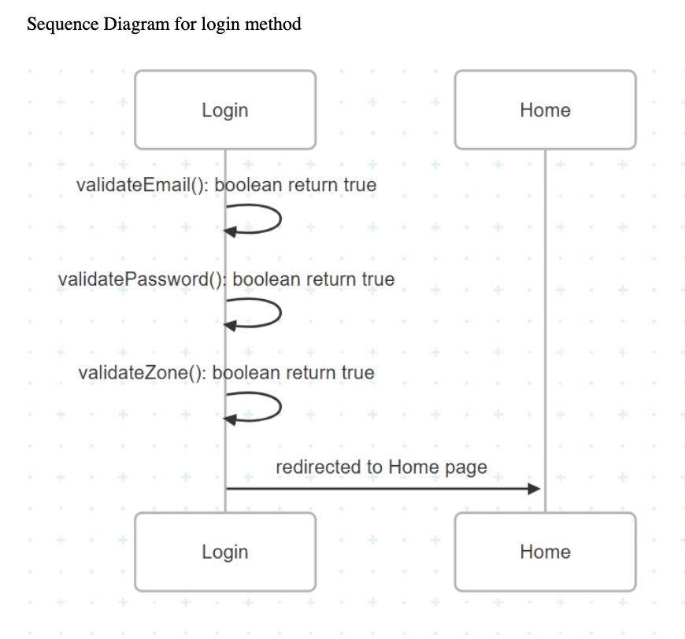

**Desgin_Feature002_SequenceDiagram_001**

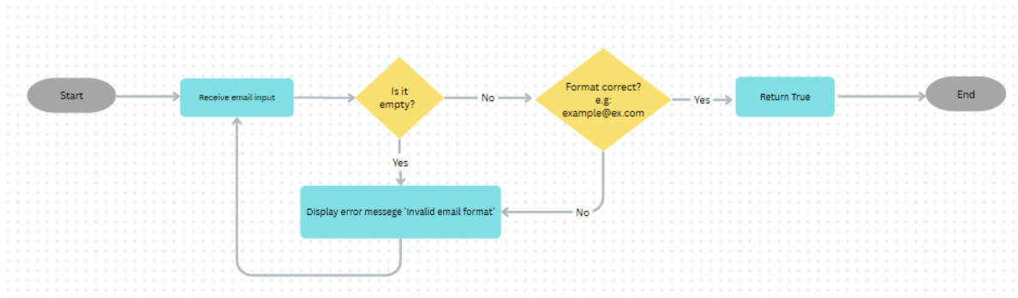

**Design_FEAT002_FLOWCHART_001**

**Design_FEAT002_FLOWCHART_002**

**Design_FEAT002_FLOWCHART_003**

**3-Restaurant Page**

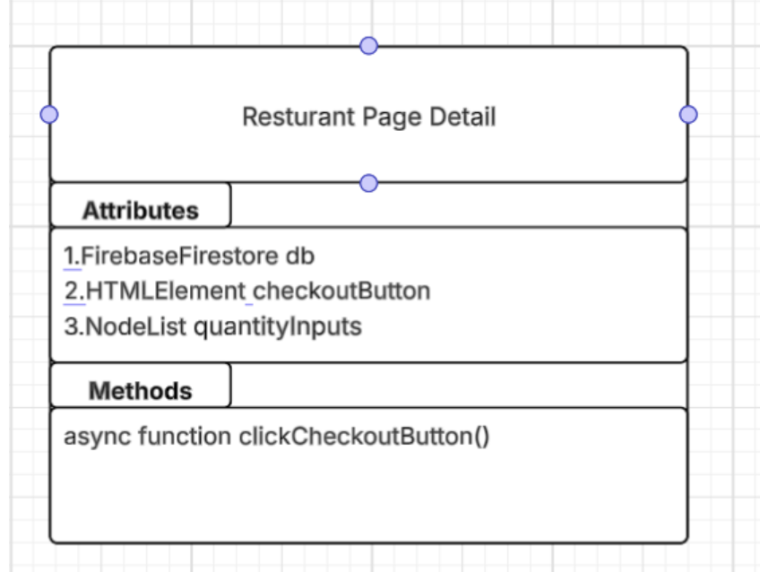

**DESIGN_FEAT004-CLASSDIAGRAM_001**

**DESIGN_FEAT004_SEQUENCEDIAGRAM_001**

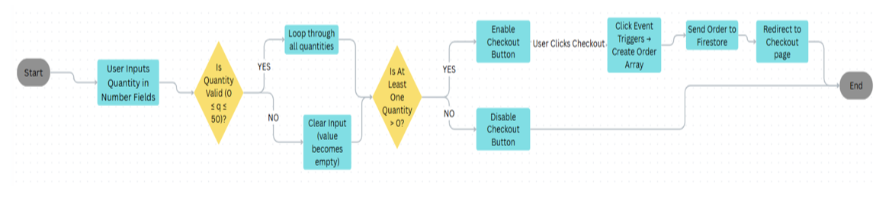

**DESIGN_FEAT004_FLOWCART_001**

**3-HomePage**

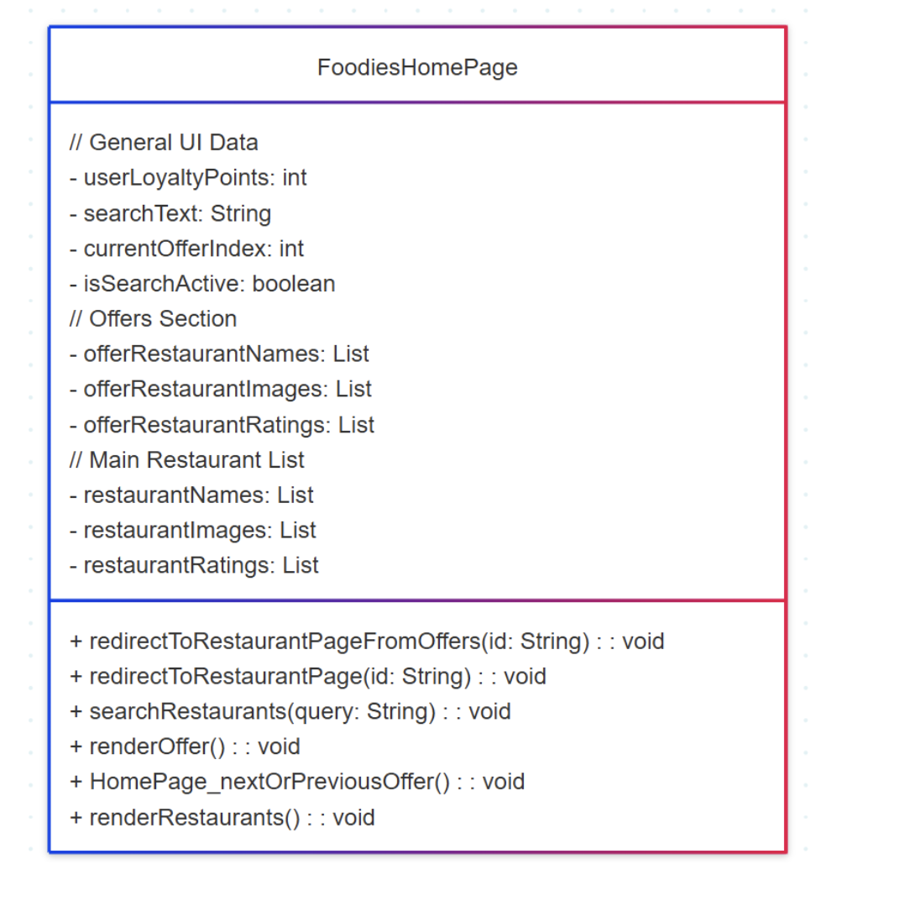

**DESIGN_FEAT003_CLASSDIAGRAM_001**

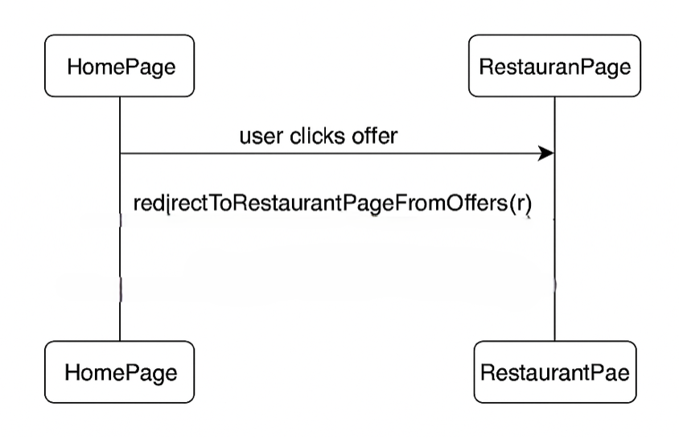

**DESIGN_FEAT003_SEQUENCEDIAGRAM_001**

**DESIGN_FEAT005_SEQUENCEDIAGRAM_002**

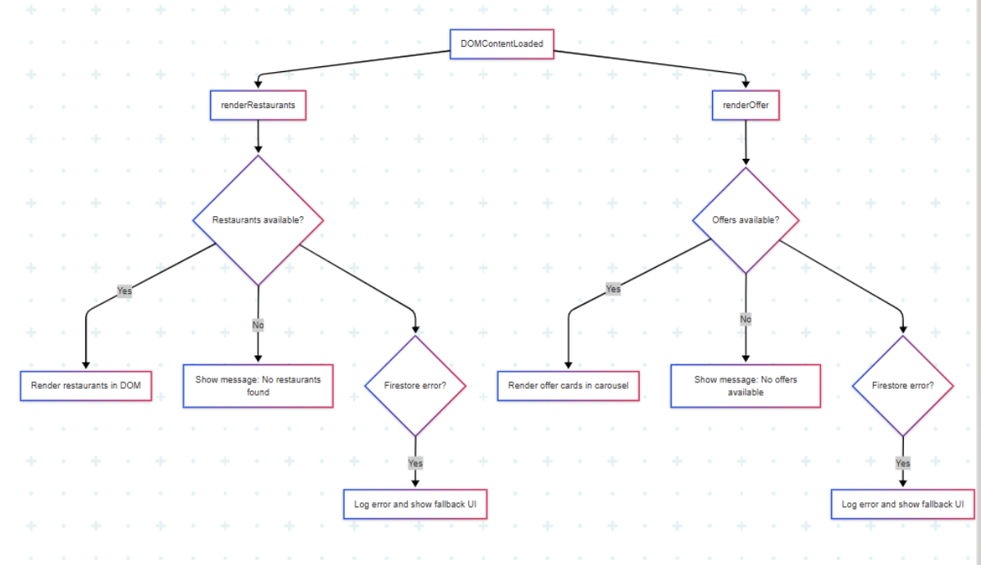

**DESIGN_FEAT003_FLOWCHART_001**

**DESIGN_FEAT003_FLOWCHART_002**

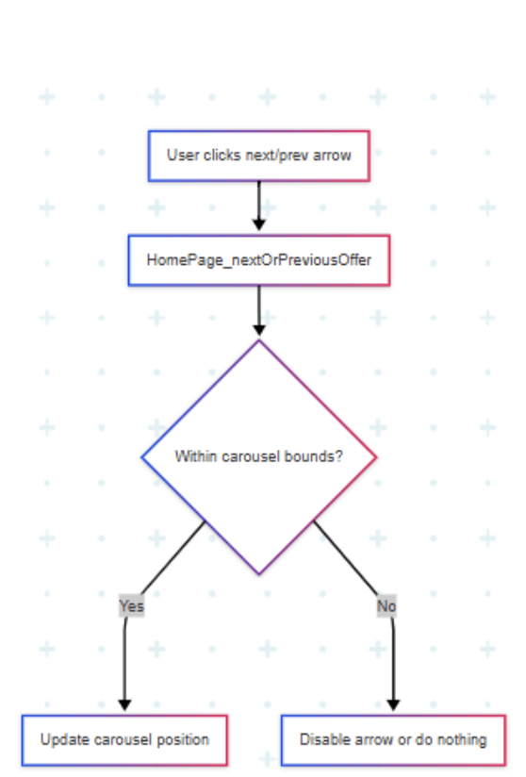

**DESIGN_FEAT003_FLOWCHART_003**

**6-Loyality Points**

**DESIGN_FEAT006_CLASSDIAGRAM_001**

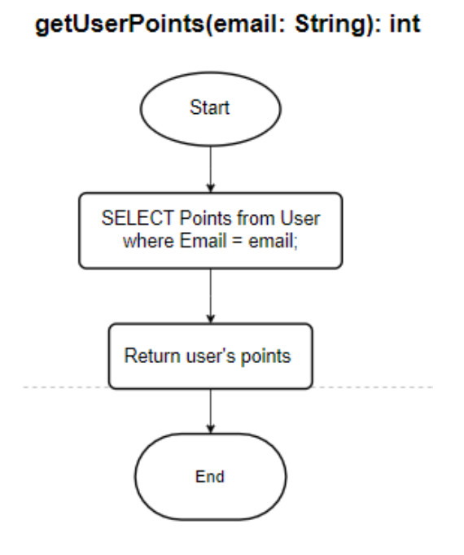

**Design_FEAT006_FLOWCHART_001**

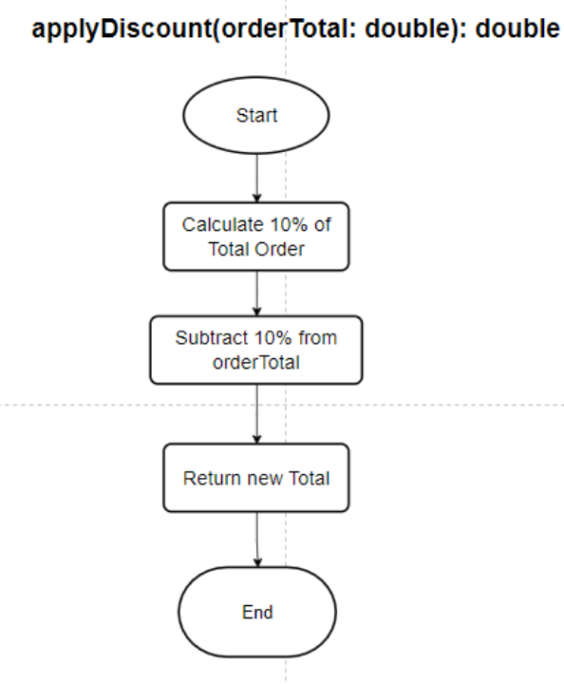

**Design_FEAT006_FLOWCHART_002**

Design_FEAT006_FLOWCHART_003

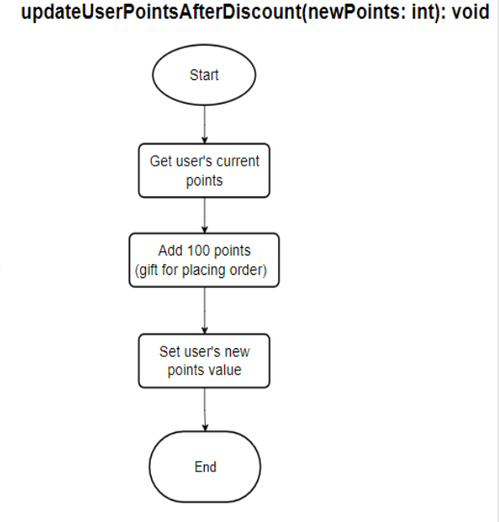

**Design_FEAT006_FLOWCHART_004**

**Design_FEAT006_FLOWCHART_005**

**CHECKOUT**

**DESIGN_FEAT007_CLASSDIAGRAM_001**

**\ DESIGN_FEAT007_SequenceDiagram_001**

**DESIGN_FEAT007_FLOWCHART_001**

**DESIGN_FEAT007_FLOWCHART_002**

DESIGN_FEAT007_FLOWCHART_003

**DESIGN_FEAT007_FLOWCHART_004**

**DESIGN_FEAT007_FLOWCHART_005**